**MYSQL CONNECTOR**

**Importing**



**Connecting to Local Server**

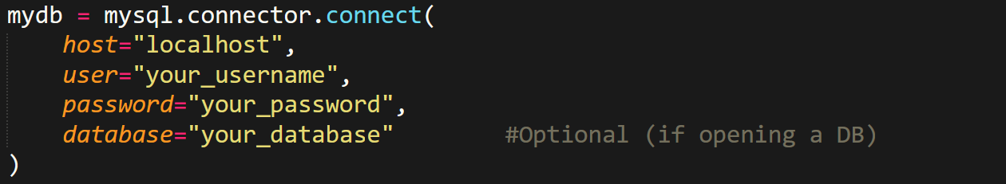

* Username is generally **"root"**.

**Executing**

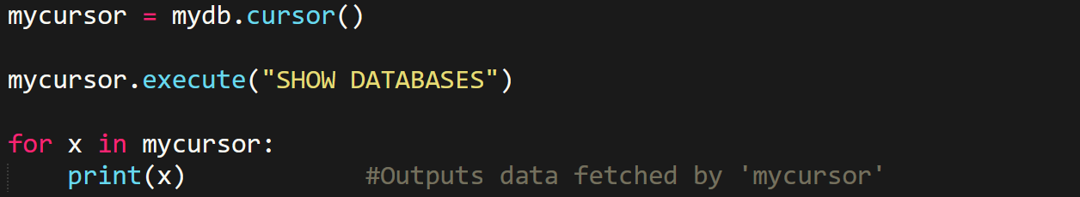

**Inserting Values**



**Methods**

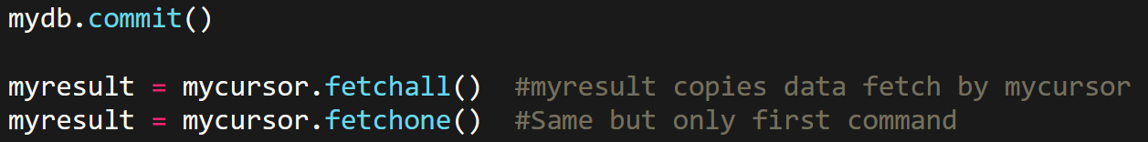

**Row Count**



**Executing Selective Commands**



**Select From**

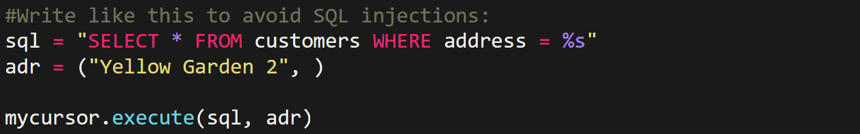

**Note**

**[( )]: ( )** means one all values in one line of command.

**[ ]:** List for it.

**Newline Character**

